
Name: Ajayi Oluwapelumi Joseph
Matriculation Number: AUL/CMP/22/013
Course Code: CMP 414
Course Title: Operating Systems II

Question 1: Using FCFS, given the following process table:
Process | Arrival Time | Burst Time | Turnaround Time
P1 | 0 | 5 | 5
P2 | 5 | 7 | 7
P3 | 10 | 6 | 8

Find the following:
- Completion time
- Average Completion time
- Inter-arrival time
- Average Inter-Arrival Time
- Waiting time
- Average waiting time
Question 2: Write a code for synchronization.
Question 3: Write a code for one single producer and consumer.

Question 1
#include <stdio.h>

int main() {
int n, i;
int bt[10], at[10], ct[10], wt[10], tat[10], iat[10];
float avg_ct = 0, avg_iat = 0, avg_wt = 0, avg_tat = 0;

printf("CMP 414 Assignment Solver\n");
printf("Enter number of processes: ");
scanf("%d", &n);

// Input Phase
for (i = 0; i < n; i++) {
printf("\nProcess P[%d]\n", i + 1);
printf("Enter Arrival Time: ");
scanf("%d", &at[i]);
printf("Enter Burst Time: ");
scanf("%d", &bt[i]);
}

// Calculation Phase
int current_time = 0;

for (i = 0; i < n; i++) {
// Calculate Inter-arrival time (Gap between this arrival and previous)
if (i == 0) {
iat[i] = 0; // First process has no previous arrival
} else {
iat[i] = at[i] - at[i-1];
}

// Logic: CPU waits if process hasn't arrived yet
if (current_time < at[i]) {
current_time = at[i];
}

// Completion Time = Start Time + Burst Time
ct[i] = current_time + bt[i];

// Update current time for next process
current_time = ct[i];

// Turn Around Time = Completion Time - Arrival Time
tat[i] = ct[i] - at[i];

// Waiting Time = Turn Around Time - Burst Time
wt[i] = tat[i] - bt[i];

// Accumulate for averages
avg_ct += ct[i];
avg_iat += iat[i];
avg_wt += wt[i];
avg_tat += tat[i];
}

// Averages
avg_ct /= n;
avg_iat /= (n - 1); // Usually averaged over n-1 gaps, but can be n depending on professor
avg_wt /= n;
avg_tat /= n;

// Output Result
printf("\n\n--- Results ---\n");
printf("P\tArr\tBurst\tInterArr\tComp\tWait\tTurnAr\n");
for (i = 0; i < n; i++) {
printf("P[%d]\t%d\t%d\t%d\t\t%d\t%d\t%d\n",
i+1, at[i], bt[i], iat[i], ct[i], wt[i], tat[i]);
}

printf("\nAverage Completion Time: %.2f", avg_ct);
printf("\nAverage Inter-Arrival Time: %.2f", avg_iat); // (Note: First process gap is usually ignored)
printf("\nAverage Waiting Time: %.2f\n", avg_wt);

return 0;
}
Output
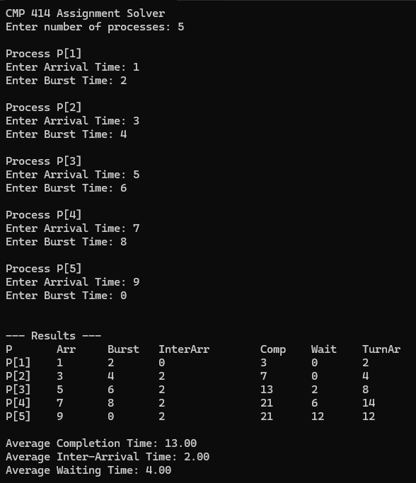

Question 2
#include <stdio.h>
#include <pthread.h>
#include <stdlib.h>

pthread_mutex_t myMutex;
static volatile int balance = 0;

void *deposit(void *parameter) {
char *who = (char *)parameter;
int i;

printf("%s is ready to deposit money. Current Balance: %d\n", who, balance);

for (i = 0; i < 10000; i++) {
// LOCK: Only one person enters here at a time
pthread_mutex_lock(&myMutex);

balance = balance + 1;

// UNLOCK: Release for the next person
pthread_mutex_unlock(&myMutex);
}

printf("%s finished depositing. Balance is now: %d\n", who, balance);
return NULL;
}

int main() {
pthread_t P1, P2;

// Initialize the lock
pthread_mutex_init(&myMutex, NULL);

// Create two threads (Bintu and Bello)
pthread_create(&P1, NULL, deposit, (void*)"bintu");
pthread_create(&P2, NULL, deposit, (void*)"bello");

// Wait for both to finish
pthread_join(P1, NULL);
pthread_join(P2, NULL);

// Destroy the lock
pthread_mutex_destroy(&myMutex);

printf("Final Total Deposit: %d\n", balance);

return 0;
}
Output
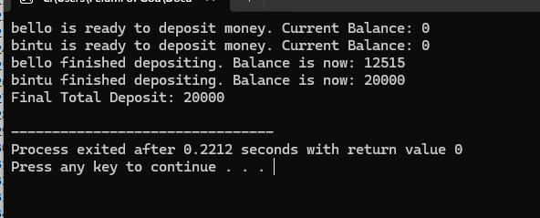

Question 3
#include <stdio.h>
#include <stdlib.h>
#include <pthread.h>
#include <semaphore.h>

#define BUFFER_SIZE 5

int buffer[BUFFER_SIZE];
int in = 0;
int out = 0;

sem_t mutex;
sem_t empty;
sem_t full;

void *producer(void *arg) {
int item, i;
for(i = 0; i < 20; i++) {
item = i; // Produce an item (number 0 to 19)

sem_wait(&empty); // Wait if buffer is full
sem_wait(&mutex); // Lock critical section

buffer[in] = item;
printf("Producer produces item: %d at index %d\n", item, in);
in = (in + 1) % BUFFER_SIZE;

sem_post(&mutex); // Unlock
sem_post(&full); // Signal that there is new data
}
return NULL;
}

void *consumer(void *arg) {
int item, i;
for(i = 0; i < 20; i++) {

sem_wait(&full); // Wait if buffer is empty
sem_wait(&mutex); // Lock critical section

item = buffer[out];
printf("Consumer consumes item: %d from index %d\n", item, out);
out = (out + 1) % BUFFER_SIZE;

sem_post(&mutex); // Unlock
sem_post(&empty); // Signal that there is empty space
}
return NULL;
}

int main() {
pthread_t prod, cons;

// Initialize semaphores
sem_init(&mutex, 0, 1);
sem_init(&full, 0, 0); // Initially 0 items are full
sem_init(&empty, 0, BUFFER_SIZE); // Initially all slots are empty

pthread_create(&prod, NULL, producer, NULL);
pthread_create(&cons, NULL, consumer, NULL);

pthread_join(prod, NULL);
pthread_join(cons, NULL);

sem_destroy(&mutex);
sem_destroy(&full);
sem_destroy(&empty);

return 0;
}

Output
